**Add About Section**

**Send Feedback**

After making the header section, you need to complete the 'about' section.

You have to add border and shadow to your photo and style the paragraph. You can also add your own text instead of the one used.

You will need to make adequate changes to the HTML code as well.

You can put your own image instead of the one in the image below.

Good Luck!

**Some important information -**

1. The color of the shadow is 'lightgrey'.

2. The color of the paragraph is 'grey'.

3. The color of the highlighted text in the paragraph is '#2857a4'.

**The resume would look like this -**

[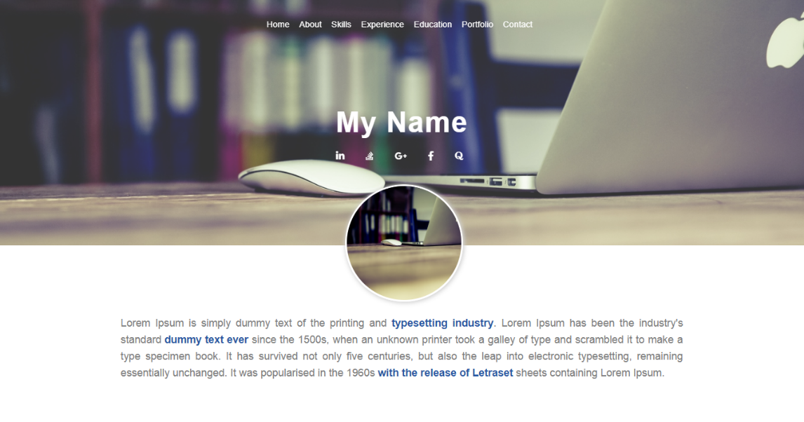](https://ninjasfiles.s3.amazonaws.com/0000000000001636.png)